Artificial Intelligence Lab

Lab Manual 1



Department of Cyber Security
HITEC University Taxila

Lab 1: Introduction to Python and Installation

Objectives
- Setting up the development environment.
- Getting started with Python
- Understanding basics of Python programming language.

Software
  - Python 3.13.2, PyCharm IDE.

Theory

Python Basics

Python Features
Python has a big list of good features; few are listed below:
    - It supports functional and structured programming methods as well as OOP.
    - It can be used as a scripting language or can be compiled to byte-code for building large applications.
    - It provides very high-level dynamic data types and supports dynamic type checking.
    - It can be easily integrated with C, C++, COM, ActiveX, CORBA, and Java.

Python Applications
- Web Applications
- Desktop GUI Applications
- Software Development
- Scientific and Numeric
- Business Applications
- Console Based Application
- Audio or Video based Applications
- 3D CAD Applications
- Enterprise Applications
- Applications for Images

Installation of Python 3.9.1
Download link: https://www.python.org/downloads/
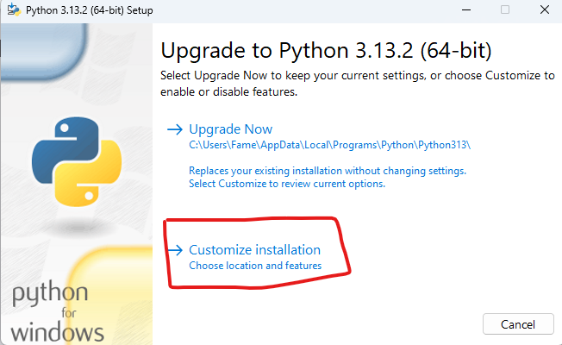

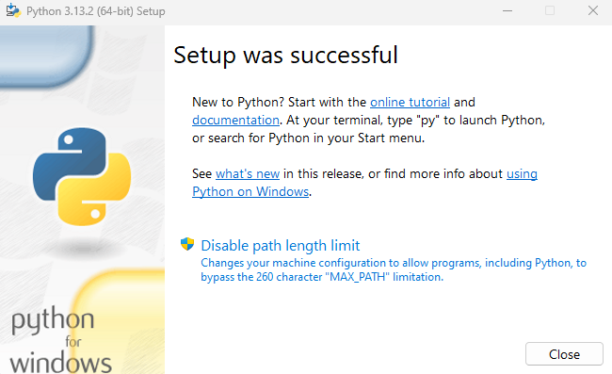

Installation of PyCharm or VS-Code Editor
PyCharm Link: https://www.jetbrains.com/pycharm/download/?section=windows
Or
VS Code Link: https://code.visualstudio.com/download

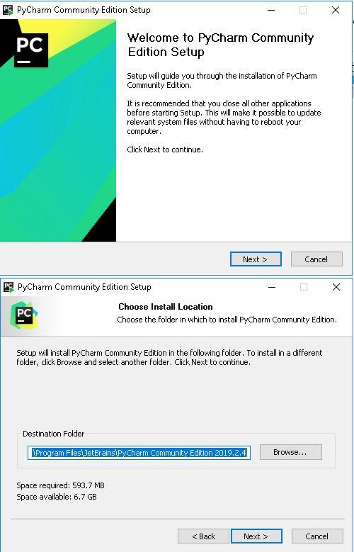

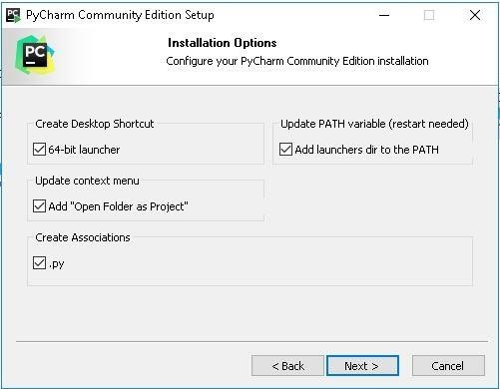
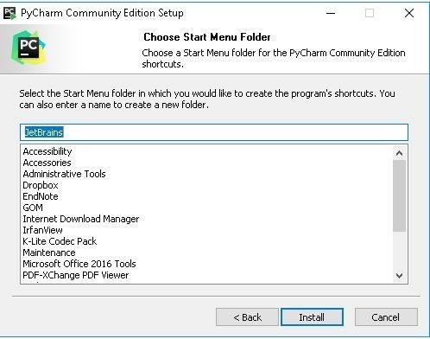

Practice:
How to check version of installed python? python –version

Display Something:
print ("Hello, Hitonians!")
Comments:
Single line:
# i am a comment
Multiple lines:
""" if 1>2:
print("one is greater than two")
if 3>2:
print("Three is greater than 2")
"""
Indentation:
if 1>2:
print("Five is greater than two")

String datatype:

x = 5 # x is of type int
x = "Computer" # x is now of type str
print(x)

x="Hitec"
y="University"
z="Taxila"
print(x)
print( y)
print( z)
print(x,y,z)

Assigning single value to multiple variables  x = y = z = 50 print (x)  print (y) print (z)  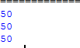 | Assigning multiple values to multiple variables:  a , b , c = 5 , 10 , 15  print (a) print (b) print (c)  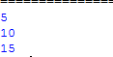
Print Data Types  a=10  b="Hi Python" c = 10.5  print(type(a));  print(type(b));  print(type(c));  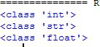 | if-statement  num = int(input("enter the number?")) if num%2 == 0:  print("Number is even")  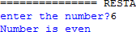
if-else statement  age = int (input("Enter your age? ")) if age>=18:  print("You are eligible to vote !!"); else:  print("Sorry! you have to wait !!");  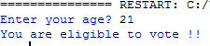 | elif statement  number = int(input("Enter the number?")) if number==10:  print("number is equals to 10") elif number==50:  print("number is equal to 50"); elif number==100:  print("number is equal to 100"); else:  print("number is not equal to 10, 50 or 100");  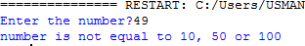
Python for loop

n = int(input("Enter the number up to which you want to print the natural numbers?")) for i in range(0,n):
print(i,end = ' ')

Nested for loop in python  n = int(input("Enter the number of rows you want to print? "))  for i in range(0, n):  print()  for j in range(0, i + 1):  print("*", end="") | Python while loop  i=1;  while i<=10: print(i); i=i+1;

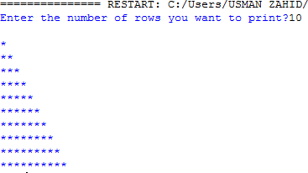 | 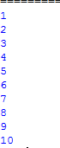

Lab Tasks
- Write a Python Code to write the table of a number given by the user.
- Write a python code to check wheatear a number is prime or not.
- Write a Python program that prints numbers from 1 to 10 using a while loop.
Modify the while loop to print only even numbers between 1 and 20.
- Write a Python program to determine whether the given number is a Harshad Number. If a number is divisible by the sum of its digits, then it will be known as a Harshad Number.
For example:
The number 156 is divisible by the sum (12) of its digits (1, 5, 6) Some Harshad numbers are 54, 120, etc.

Conclusion
_________________________________________________________________________________________________________________________________________________________________________________________________________________________________________________________________________________________________________________________________________________________________________________________________________________________________________________________________________________________________________________________________________________________________________________________________________________________________________________________________________________________________________________________________________________________________________________________________________________________________________________________________________________________________________________________________________________________________________________________________________________________________________________________________________________________________________________________________________________________________________________________________________________________________________________________________________________________________________________________________________________________________________________________________________________________________________________________________________________________________________________________________________________________________________________________________

